Advance Software Engineering LAB-2 Rainigari.Vishnu chander(16157693)

I have Implemented a Mobile Web Client Application using Javascript, HTML5, CSS3, jQuery Mobile. I have created a direction service using the existing google map service.

I did this using jsfiddle :

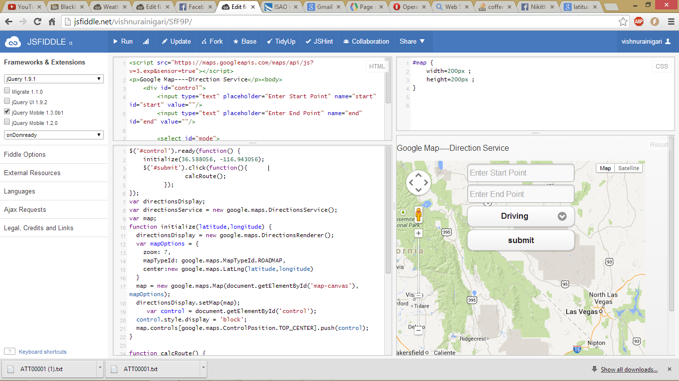

I downloaded opera emulator to simlulate my results in a mobile device.

